Electronics Documentation

1. Electronics Block Diagram
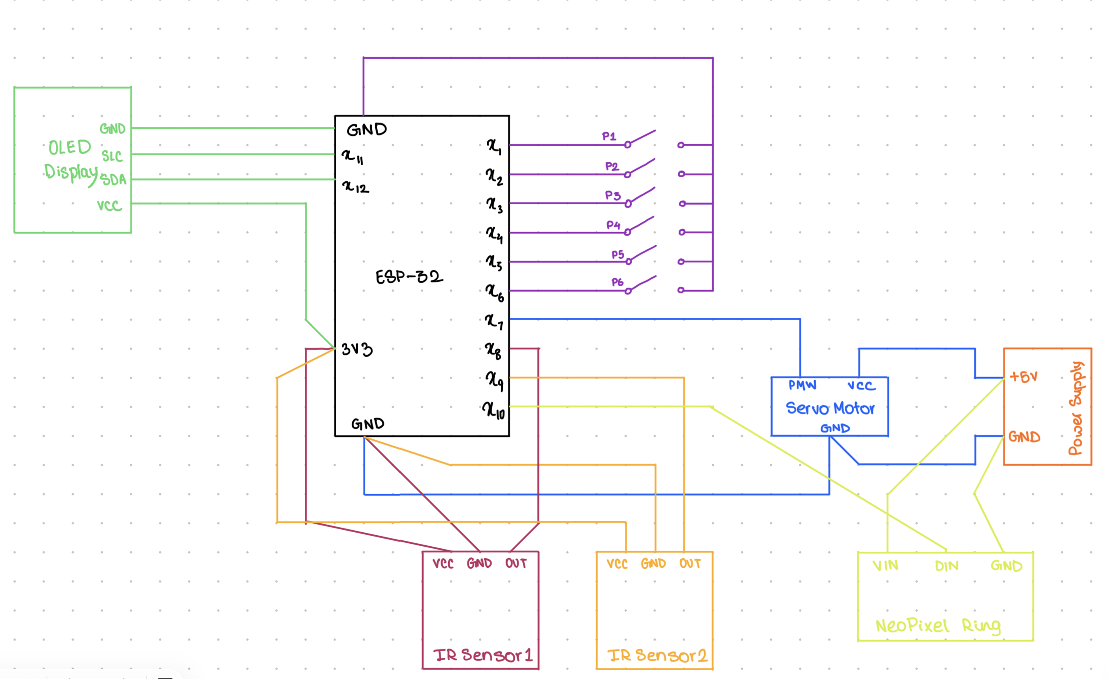

2. Components Table
Component | Quantity | Purpose | Justification
Stepper Motor | 1 | To lift the pins from the base via a thread | The shaft provides a greater surface area to wrap the thread and lift the system with just a 90-degree turn.
NeoPixel Strip | 1 | To show how many pins have been knocked down per throw | Acts like a straight progress bar of how many pins have been knocked down.
IR Sensor | 2 | To detect gutter ball and display it on the OLED display | Detects the presence of the ball when it passes over it and hence obstructs the returning of the IR rays.
OLED Display | 1 | To show the numerical score for each of the throws and the total score along with strike and gutter ball detection. It also shows when the system is ready to use. | Text messages and numerical values can be easily displayed.

